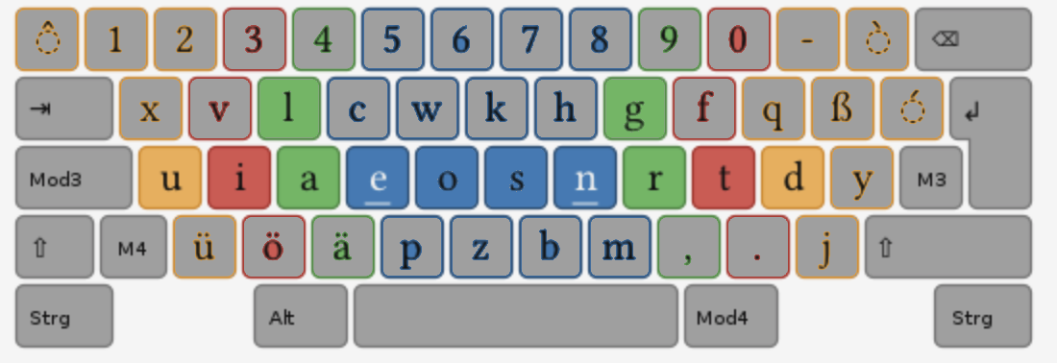ala rgr ala rgr ala rgr ala rgr ala rgr ala rgr ala rgr ala rgr ala rgr ala rgr

ala rgr ala rgr ala rgr ala rgr ala rgr ala rgr ala rgr ala rgr ala rgr ala rgr

ala rgr ala rgr ala rgr ala rgr ala rgr ala rgr ala rgr ala rgr ala rgr ala rgr

ale rgn ale rgn ale rgn ale rgn ale rgn ale rgn ale rgn ale rgn ale rgn ale rgn ale rgn

ale rgn ale rgn ale rgn ale rgn ale rgn ale rgn ale rgn ale rgn ale rgn ale rgn ale rgn

ali rgt ali rgt ali rgt ali rgt ali rgt ali rgt ali rgt ali rgt ali rgt ali rgt

ali rgt ali rgt ali rgt ali rgt ali rgt ali rgt ali rgt ali rgt ali rgt ali rgt

alu rgd alu rgd alu rgd alu rgd alu rgd alu rgd alu rgd alu rgd alu rgd

alu rgd alu rgd alu rgd alu rgd alu rgd alu rgd alu rgd alu rgd alu rgd

ula dgr ula dgr ula dgr ula dgr ula dgr ula dgr ula dgr ula dgr ula dgr

ula dgr ula dgr ula dgr ula dgr ula dgr ula dgr ula dgr ula dgr ula dgr

ila tgr ila tgr ila tgr ila tgr ila tgr ila tgr ila tgr ila tgr ila tgr ila tgr

ila tgr ila tgr ila tgr ila tgr ila tgr ila tgr ila tgr ila tgr ila tgr ila tgr

ela ngr ela ngr ela ngr ela ngr ela ngr ela ngr ela ngr ela ela ngr ela ngr

ela ngr ela ngr ela ngr ela ngr ela ngr ela ngr ela ngr ela ngr ela ngr ela ngr